COEN 161 Web Programming 1 Fall 2014

Lab 1: Part 2 (50 pts)

TA: Wenliang Tong Email: wtong@scu.edu
Office hrs: Tues: 8.15AM-9.15AM and Fri: 1.15-2.15pm
--------------------------------------------------------------------------------------------------------------------------------------------------------

Objectives:
Learn to
- Create a web page with HTML and validate it;
- Use images, links and lists in your web page.

Exercise 1 (20 pts)

In this part, you will edit your first web document and validate the document as an HTML5 (as is given in the DOCTYPE).

STEP 1: Create an HTML document, given below, using a text editor of your choice (you can copy and paste it into a text file and edit it) and save it in a file, MyFirstPage.html.
You can also use Notepad++ (if it is available), Alleycode or Aptana Studio to create or edit your html documents.

<!DOCTYPE html>
<html lang="en">

<!-- Include your comments here -->

<head>
<meta charset=”utf-8" />
<title> My First Page</title>
</head>
<body>
<h1> Insert your name here </h1>
<p> Write some text of your choice here </p>
<!-- Include the course numbers of your classes this quarter -->
<ul>
<li>course number </li>
<li>course number </li>
<li>course number </li>
</ul>

<!-- Let us go to Yahoo site >
<p>
<a href="http://www.yahoo.com"> Go to Yahoo </a>
<p>

<!-- Include one more favorite link of yours here -->
<h2> A favorite link of mine </h2>
<hr/>
<address> Written by include your name here<br/>
your contact info - you can include your email here</address>
</body>
</html>

STEP 2: Add the information as specified in the comments (in green).
You should now try and validate the page as HTML5. Go to http://validator.w3.org/. To use this validator for HTML5, you need to use More Options and select Document Type as HTML5 (experimental) as shown below.
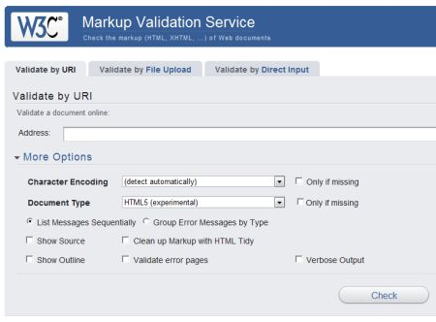

Now, choose the option, Validate by File Upload, select the file to validate and press the Check button on the page. If there are errors, fix the errors and revalidate it. On validation, your page should not have any errors; warnings are ok at this point.

STEP 3: At this point, your page must be valid with no errors. Open the page in FireFox and also in Chrome.
Unlike XHTML, HTML 5 offers a lot of flexibility with syntax. But to make the document compatible (if need be) with XHTML syntax, it is better to follow the rules below:

- Tags and attributes can be upper or lowercase. But to make the document compatible (if need be) with XHTML syntax, choose to use lower case.
- All tags must be closed.
- Documents must be well-formed: You have to open and close tags correctly in HTML, and nest them properly.
- Attribute values must be quoted (optional)

Exercise 2 (30 pts)
In this exercise, you will use lists (ordered, unordered and definition lists). Refer to http://ww.w3schools.com/html/html_lists.asp for syntax and description of the three types of lists.
STEP 1:
Open the page, mycooking.html. Replace the content in the h1 element, with a recipe name of your choice. Below the recipe name, include the following:
- Add the image (“choconut.jpg”) in the div with id, “imagediv”. Refer to http://w3schools.com/html/html_images.asp, if you need help with including images on the page.
- In the div, “contentdiv”, add 3 and 4 as described below.
- Create a definition list with the following definitions.
al dente
A correct degree of doneness for pasta and vegetables.
baste
Brush oil around item to be cooked to prevent dryness.
pinenut
Also called pignoli.
- Create lists for the following descriptions:
The ingredients:
- 100 g. flour
- 10 g. sugar
- 1 cup water
- 2 eggs
- salt, pepper
The procedure:
- Mix dry ingredients thoroughly.
- Pour in wet ingredients.
- Mix for 10 minutes.
- Bake for one hour at 300 degrees.
Notes:
The recipe may be improved by adding raisins.
STEP 2:
You should now try and validate the page as HTML 5 document, as you have done earlier. Fix any errors and revalidate it. On validation, your page should not have any errors; warnings are ok at this point.

STEP 3: At this point, your page must be valid with no errors. Open the page in FireFox or Chrome. Does the page (with lists) show according to the requirements given?

